**“TATHASTU”**

**(Gesture and Voice Controlled Virtual Mouse)**

### A Major Project Report Submitted in Partial Fulfillment for the Award of the

### Degree of Bachelor of Technology in Computer Science and

### Engineering

**To**



**Dr. A.P.J. ABDUL KALAM TECHNICAL UNIVERSITY, LUCKNOW**

***Submitted by***

|  |  |
| --- | --- |
| **Harsh Gupta** | **(1903420100054)** |
| **Himanshu Dwivedi** | **(1903420100058)** |
| **Anshul Kumar Rawat** | **(1903420100030)** |

**UNDER THE SUPERVISION OF**

**Associate Prof. Sanjay Panday**

**Department of Computer Science & Engineering**

**DEPARTMENT OF COMPUTER SCIENCE AND ENGINEERING**

**UNITED COLLEGE OF ENGINEERING AND RESEARCH,**

**PRAYAGRAJ**

**MAY 2023**

**“TATHASTU”**

**(Gesture and Voice Controlled Virtual Mouse)**

### A Major Project Report Submitted in Partial Fulfillment for the Award of the

### Degree of Bachelor of Technology in Computer Science and

### Engineering

**To**



**Dr. A.P.J. ABDUL KALAM TECHNICAL UNIVERSITY, LUCKNOW**

***Submitted by***

|  |  |
| --- | --- |
| **Harsh Gupta** | **(1903420100054)** |
| **Himanshu Dwivedi** | **(1903420100058)** |
| **Anshul Kumar Rawat** | **(1903420100030)** |

**UNDER THE SUPERVISION OF**

**Associate Prof. Sanjay Panday**

**Department of Computer Science & Engineering**

**DEPARTMENT OF COMPUTER SCIENCE AND ENGINEERING**

**UNITED COLLEGE OF ENGINEERING AND RESEARCH,**

**PRAYAGRAJ**

**MAY 2023**

**CANDIDATE’S DECLARATION**

We, hereby certify that the project entitled “Gesture and Voice Controlled Virtual Mouse” submitted by us in partial fulfillment of the requirement for the award of degree of the B. Tech. (Computer Science & Engineering) submitted to Dr. A.P.J. Abdul Kalam Technical University, Lucknow at United College of Engineering and Research, Prayagraj is an authentic record of our own work carried out during a period from June, 2022 to May, 2023 under the guidance of Prof Sanjay Pandey, Assistant professor, Department of Computer Science & Engineering). The matter presented in this project has not formed the basis for the award of any other degree, diploma, fellowship or any other similar titles.

Submitted by:

Name: Harsh Gupta

Roll No.: 1903420100054

Name: Anshul Kumar Rawat

Roll No.: 190342010030

Name: Himanshu Dwivedi

RollNo.:1903420100058

# CERTIFICATE

This is to certify that the project titled Gesture and Voice Controlled Virtual Mouse is the bona fide work carried out by (Student name) & (University Roll no) in partial fulfillment of the requirement for the award of degree of the B. Tech. (Computer Science & Engineering) submitted to Dr. A.P.J Abdul Kalam Technical University, Lucknow at United College of Engineering and Research, Prayagraj is an authentic record of their own work carried out during a period from June, 2022 to May, 2023 under the guidance of Prof. Sanjay Pandey, Assistant professor, Department of Computer Science & Engineering). The Major Project Viva-Voce Examination has been held on __________________.

### Signature of the Guide _________________________________

### [Mr. Sanjay Pandey]

### Signature of Project Coordinator ________________________

### [Mr. Shyam Bahadur Verma]

### Signature of the Head of Department _____________________

### [Dr. Vijay Kumar Dwivedi]

### Place:

### Date:

# ABSTRACT

By controlling cursor movement with a real-time camera and microphone, this project advances the Human Computer Interaction (HCI) paradigm in the field of computer science.

The hand movement and speech is the most effortless and primitive way of communication. It's a replacement for the present ways, which entail manually moving a physical computer mouse or pressing buttons. Instead, the system controls and performs numerous mouse activities using a camera for computer vision technology and a microphone for speech recognition and processing. It can perform all functions that a physical mouse can.

The Virtual Mouse continuously gathers real-time visuals and voice commands, which are then filtered and converted in a number of steps. When the procedure is completed, the program uses image processing and natural language processing to extract the valid command needed to complete the task.

Especially abled people with hand problems can use this virtual mouse to control the computer's mouse functionalities.

# ACKNOWLEDGEMENT

We express our sincere gratitude to the Dr. A.P.J Abdul Kalam Technical University, Lucknow for giving us the opportunity to work on the Major Project during our final year of B.Tech. (CSE) is an important aspect in the field of engineering.

We would like to thank Dr. H.P. Shukla, Principal and Dr. Vijay Kumar Dwivedi, Head of Department, CSE at United College of Engineering and Research, Prayagraj for their kind support.

We also owe our sincerest gratitude towards Prof. Sanjay Pandey for his/her valuable advice and healthy criticism throughout our project which helped us immensely to complete our work successfully.

We would also like to thank everyone who has knowingly and unknowingly helped us throughout our work. Last but not the least, a word of thanks for the authors of all those books and papers which we have consulted during our project work as well as for preparing the report

# List of Figures

|  |  |  |
| --- | --- | --- |
| 1. | HCI usage in various fields | 12 |
| 2. | Hand Landmarks | 14 |
| 3. | Architecture of Gesture and Voice control application | 19 |
| 4. | Flowchart of Virtual mouse | 20 |
| 5. | Level-0 DFD of Virtual mouse | 21 |
| 6. | Level-1 DFD of Virtual mouse | 21 |
| 7. | Working model of palm detection | 24 |
| 8. | Palm Landmarks | 25 |
| 9. | Working model of Virtual mouse | 26 |
| 10. | Flowchart of Chatbot | 32 |
| 11. | Level-0 DFD of Chatbot | 33 |
| 12. | Level-1 DFD of Chatbot | 33 |
| 13. | Working model of Chatbot | 38 |
| 14. | Plagiarism Relation Chart | 45 |
| 15. | Architecture of Application | 48 |
| 16. | Working model of Gesture Control | 49 |
|  |  |  |
|  |  |  |
|  |  |  |
|  |  |  |

|  |  |  |
| --- | --- | --- |
|  |  |  |
|  |  |  |
|  |  |  |
|  |  |  |
|  |  |  |
|  |  |  |
|  |  |  |
|  |  |  |
|  |  |  |
|  |  |  |
|  |  |  |
|  |  |  |
|  |  |  |
|  |  |  |
|  |  |  |

# Table of Contents

|  |  |  |
| --- | --- | --- |
| i. | Title Page | 1 |
| ii. | Declaration of the Student (Signed by Student) | 3 |
| iii. | Certificate of the Guide (Signed by Guide, HoD, Project Coordinator) | 4 |
| iv. | Abstract (Evaluated & Signed by Guide) | 5 |
| v. | Acknowledgement | 6 |
| vi. | List of Figures | 7 |
| **1.** | **INTRODUCTION** | **10** |
| 1.1 | Objective | 11 |
| **2.** | **LITERATURE SURVEY** | **12** |
| 2.1 | What is Human-Computer Interaction (HCI)? | 12 |
| 2.2 | MediaPipe | 13 |
| 2.3 | OpenCV | 14 |
| 2.4 | Past Researches | 15 |
| 2.5 | Conclusion | 16 |
| **3.** | **Limitations of Physical Mouse** | **17** |
| **4.** | **Motivation of Virtual Mouse** | **18** |
| **5.** | **Architecture** | **19** |
| **6.** | **Methodology** | **20** |
| 6.1 | Gesture control | 20 |
| 6.1.1 | Flowchart | 20 |
| 6.1.2 | Data Flow Diagram | 21 |
| 6.1.3 | Working of OpenCV | 22 |
| 6.1.4 | ML Pipeline | 23 |
| 6.1.5 | Palm Detector Model | 24 |
| 6.1.6 | Hand Landmark Model | 24 |
| 6.1.7 | Working Model | 26 |
| 6.1.8 | Gesture controller features | 27 |
| 6.2 | Voice control | 32 |
| 6.2.1 | Flowchart | 32 |
| 6.2.2 | Data Flow Diagram | 33 |
| 6.2.3 | Voice assistant features | 34 |
| 6.2.4 | Working Model | 38 |
| **7.** | **Hardware and Software Requirement** | **39** |
| **8.** | **Applications** | **41** |
| **9.** | **Limitations** | **42** |
| **10.** | **Future Scope** | **43** |
| **11.** | **Conclusion** | **44** |
| **12.** | **Plagiarism Test** | **45** |
| **13.** | **References** | **46** |
| **14.** | **Appendix** | **47** |
|  |  |  |
|  |  |  |

# Introduction

Speaking and using hand gestures are generally recognised as the most effective and expressive forms of human communication. It is sufficiently expressive for deaf and dumb people to understand it. A real-world gesture system is suggested in this study. The system's experimental configuration makes use of a fixed-position, reasonably priced web camera with a high-definition recording function that is installed on top of a computer display or a fixed laptop camera. Additionally, it makes use of a microphone to record sound, which is then processed to carry out other mouse activities. One of the main problems for communicating with dumb and deaf individuals is the recognition and interpretation of sign language or speech.

The provided project's code was written in the Python computer programming language, and OpenCV was used to record motions using computer vision. The suggested Virtual mouse system's model employs the MediaPipe package for hand tracking. For voice commands, the Python library Speech Recognition is utilised.

# 1.1 Objective

The basic objective of the project is to build a hands-free virtual Mouse system that concentrates on a few important future applications. Through the use of different image and audio processing techniques, this project intends to do away with the necessity for a physical mouse and enable users to communicate with the computer system via camera and speech. The goal of this project is to develop a Virtual Mouse programme that can be used to many situations and surfaces.

The project's aims are as follows:

* Designed to operate using a mouse and a camera. With the aid of a camera, which captures video and still images in real-time, the Virtual Mouse technology operates. In order for the application to work, a webcam is needed.
* When the hand gesture or motion is transformed into a mouse activity, the cursor is allocated to a specific location on the screen. The Virtual Mouse programme is set up to detect the location of the fingers and knuckles on a defined hand colour and texture in order to determine the position of the mouse points.
* Create a multi-user independent speech recognition system that can retrieve folders, subfolders, documents, copy, paste, left-click, right-click, and double-click by accepting voice commands and confirming their authenticity. This system would employ a microphone to collect voice in real-time.
* To go along with the gesture-activated system, develop a voice-activated mouse system.

# Literature Survey

## 2.1 What is Human-Computer Interaction (HCI)?

Human-computer interaction (HCI) is the study of how people (users) interact with computers. The design of computer technology is the focus of this diverse topic. HCI started with computers and has expanded to include almost every facet of information technology design.

## The Meteoric Rise of HCI

HCI originated in the 1980s, at the same time when personal computers like the Apple Macintosh, Commodore 64, and IBM PC 5150 started to be used in homes and companies. For the first time, common customers could utilise complex electronic systems like gaming consoles, word processors, and accountancy tools. As a result, the need to study human-computer interaction that was also effective and easy for less experienced users developed in relevance as computers expanded in size to the point where they were room-sized, costly equipment built only for experts in specialised settings. HCI has drawn upon a variety of disciplines, including design, computer science, psychology, cognitive science, and human-factors engineering.

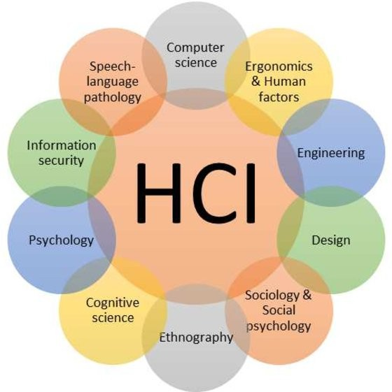

**Fig 1:** HCI usage in various fields

A number of these algorithms have been modified during the study on human-computer interaction in many different domains, including engineering, design,

Some of the disciplines addressed include sociology, computer science, cognitive science, information security, and speech-language pathology.

The goal of the present study is to develop algorithms that reduce human dependence on hardware and work towards a more natural way of speaking and gesturing with computers.

For computer vision, the OpenCV library is utilised, and the MediaPipe framework is used to detect and track hand gestures. Machine learning techniques are also used by the system to detect and recognise hand gestures and tips.

## 2.2 MediaPipe

Google's open-source MediaPipe technology is utilised in a machine learning pipeline. The MediaPipe framework is appropriate for cross-platform development since it is based on time series data. A number of audio and video formats can be utilised with the multimodal architecture known as the MediaPipe. Developers design systems for application development as well as for graph-based system analysis utilising the MediaPipe framework. The stages are carried out in the pipeline setup in a MediaPipe-enabled environment. The pipeline may operate on a variety of platforms, including desktops, laptops, and mobile devices, and is scalable.The three main parts of the MediaPipe system are performance evaluation, a framework for accessing sensor data, and a reusable group of parts called calculators.

A single-shot detector model is utilised to distinguish and detect a hand or palm in real time. The MediaPipe single-shot detector is employed. Since hand palms are simpler to train and map, it is initially trained for a palm detection model of hands in the hand detection module. Furthermore, for tiny objects like hands and fists, the non-maximum suppression is far more effective. A model of a hand map or landmark is created using the coordinates of 21 joints or knuckles in the hand area.

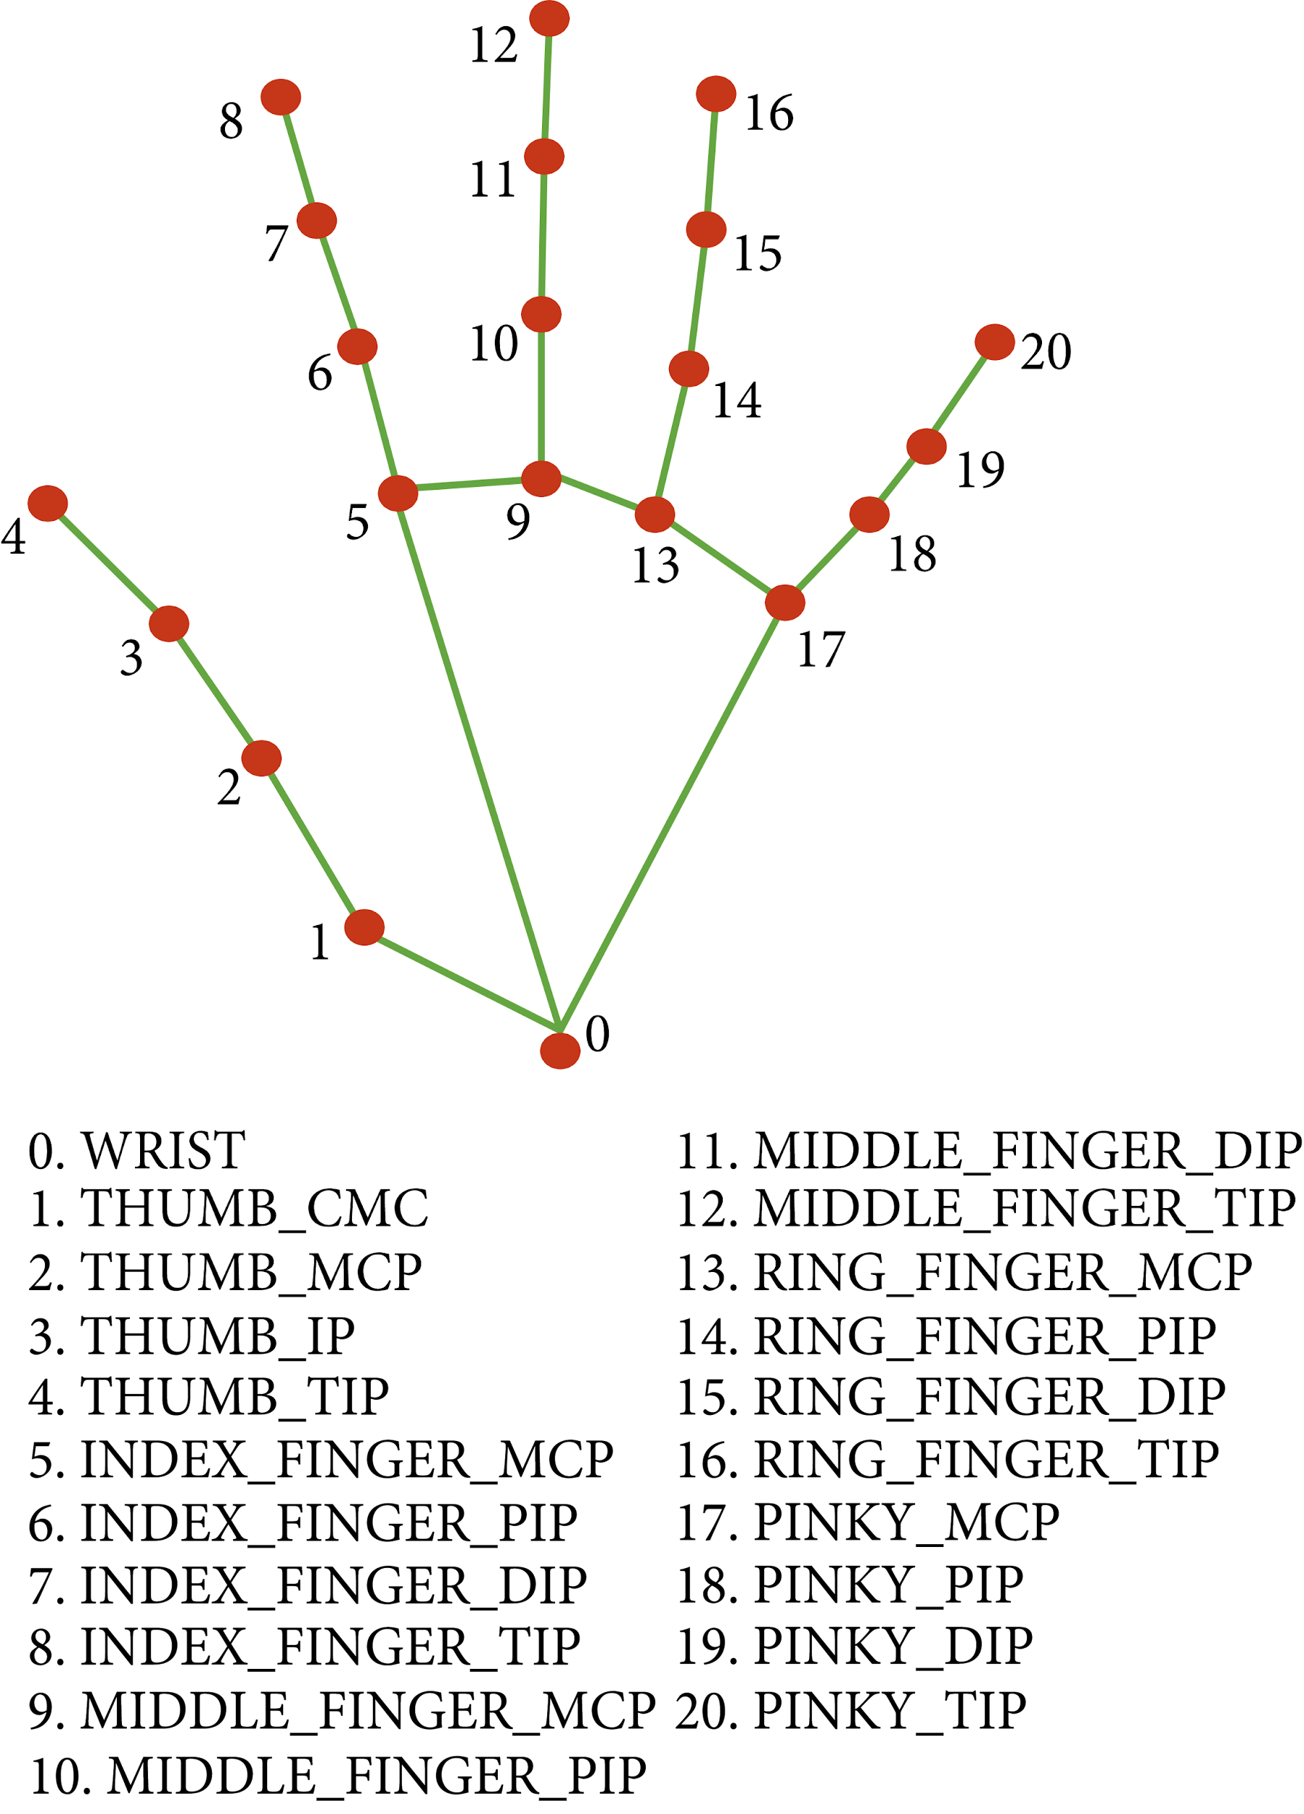

**Fig 2:** Hand Landmarks

## 2.3 OpenCV

A real-time computer vision library with an emphasis on computer vision is called OpenCV. It was created by Intel initially.

The library is cross-platform and open-source under the BSD licence.

OpenCV features a C++-based user interface and is built in C++. There are bindings for Python, Java, and MATLAB/OCTAVE.

a machine learning, computer vision, and image analysis open-source library. To do this, it contains an infinite number of algorithms that make it possible to recognise faces, categorise objects, and detect hand gestures with just a few lines of code.

## 2.4 Past Researches

In the area of human computer interaction, we have made significant progress. At first, gesture-based mouse control was done while wearing gloves. Later, gesture recognition also employed coloured tips. Even still, these systems weren't extremely precise. Due to the wearing of gloves, the identification accuracy is decreased. Gloves may not be comfortable for all users, and in certain cases, faulty colour tip detection results in less accurate recognition. Systems for detecting gestures on computers have lately attracted some attention.

A hardware-based method requiring the user to wear a DataGlove was presented by Quam in 1990. Even though Quam's suggested technique produces more accurate results, certain of the gesture controls are challenging to use with the system.

The Visual Panel interface system was proposed by Zhengyou et al. in 2001. This technology makes use of a quadrangle-shaped plane that enables users to use any tip-pointed interface tool like a mouse. Even though the system may be controlled without touching anything, material handling and the need for a large surface area remain issues.

Kamran Niyazi et al. (2012) suggested colour tracking mouse stimulation. The device tracks two coloured tapes on the user's fingertips using computer vision technology. The movement of the pointer will be managed by one of the tapes, while the mouse click events will be triggered by the other. Although the suggested system successfully addressed the majority of the problems, it is only capable of performing simple operations like cursor movements, left/right clicks, and double clicks.

According to Kazim Sekeroglu (2010), the system needs three fingers and three different coloured pointers to imitate click events. The proposed system uses colour information to identify pointers, track their movement, adjust the cursor to the pointer's position, and mimic single and double left or right mouse click actions.

Chu-Feng Lien (2015) suggested a method for managing click events and the mouse pointer with just one fingertip. The recommended system includes a feature called Motion History Images (MHI), which eliminates the need for hand gestures or colour tracking to interact with it. The suggested system can't identify swiftly moving objects since the frame rates can't keep up with them. Inconveniently, this may force the user to move their fingers continually to prevent false alarms because mouse click events only occur while the finger is maintained in specific places.

### 2.5 CONCLUSION

Although the previously suggested models significantly enhanced the human control interface with regard to mouse functions, they had several flaws and restrictions. Some of these include the need for gloves, difficult gestures, and restricted functionality. Through our idea, we hoped to overcome the aforementioned restrictions by doing away with gloves and incorporating the majority of the functionalities using basic hand gestures. This virtual system has also been integrated with speech recognition, which will take orders like "cut," "copy," and "paste," among others, and process them to carry them out.

1. **Limitations of Physical Mouse**

Although technology has advanced greatly since its start in the previous decade, there are still a lot of negative aspects to it. A mouse, or in a broader sense, any physical device, has the following known and universal limitations:

There are some drawbacks to the actual mouse, including the following:

* The physical mouse degrades with time.
* The physical mouse needs a certain surface in order to function with both hardware and software.
* The physical mouse cannot be used in a number of circumstances. Depending on the setting, performance varies.
* Even in today's operational conditions, the mouse has limited capabilities.
* Both wired and wireless mice have different usable timespans.

# Motivation of Virtual Mouse

Because we are moving towards a lifestyle in which everything can be managed remotely without the use of any physical devices like the mouse, keyboards, etc., we may argue that the virtual mouse will soon replace the actual mouse. Using a virtual mouse is not only practical, but also economical.

### Convenient

We need a real mouse to communicate with computers, and placing that mouse demands some extra room. On the other hand, utilising MediaPipe and a virtual mouse, all that is needed to capture hand landmarks is a camera. Additionally, consumers may now manage their displays and other devices remotely using a camera or other image-capture device, eliminating the need for a physical mouse and allowing users to operate systems from up to a foot away.

### Cost Effective

Since the Virtual Mouse only requires a camera, an actual mouse that is excellent and effective is no longer required. Therefore, we no longer need to purchase a new physical mouse, saving money. We simply utilise a camera, which is already included on many devices like laptops, and some easy-to-install software when using a virtual mouse.

1. **ARCHITECTURE**

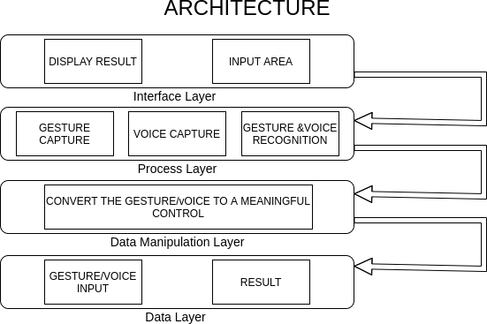

**Fig 3:** Architecture of Gesture and Voice Control application

# Methodology

**6.1 Gesture Control**

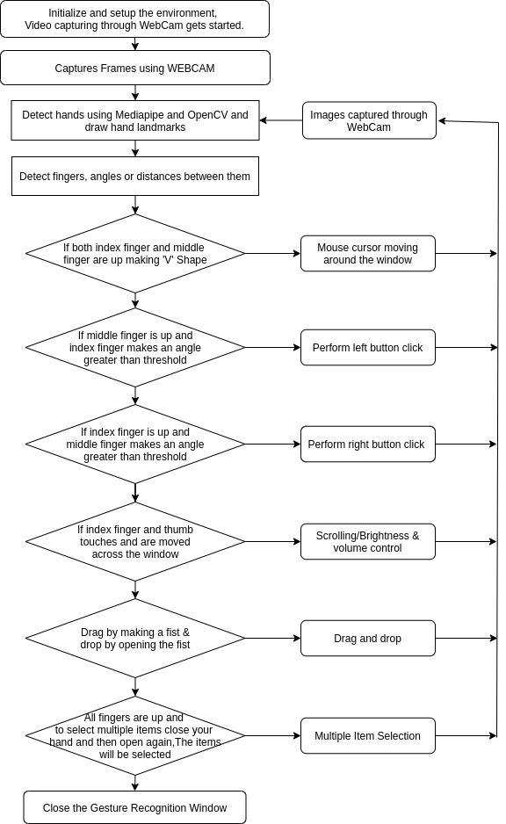**6.1.2 Flow chart**

**Fig 4:** Flowchart of Virtual Mouse

**6.1.3 Gesture Control-Data Flow Diagram (DFD)**

**LEVEL-0**

**Fig 5:** Level-0 DFD of Virtual Mouse

**LEVEL-1**

**Fig 6:** Level-1 DFD of Virtual Mouse

### Computer Vision application for object identification

Our virtual mouse environment is built using the frames that a laptop or PC's camera records. We utilised OpenCV, a Python computer vision module, and the web camera to start recording video in order to capture the video object that is developing. The frames are taken by the web camera and sent to the virtual setting.

**6.1.4 Working of OpenCV**

Only numbers are used by computers. Everything we store on a computer, including pictures, videos, documents, and so on, is kept there as numbers.

In image processing, pixels are numerically transformed. The smallest component of a computer image is a pixel.

To determine a number's intensity at a certain pixel, utilise the numbers. Grey scale or BGR (Blue, Green, and Red) formats are both supported by OpenCV.

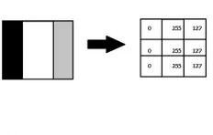

Images may be categorised utilising:

1. **Gray Scale Images**

This type of image processing entails transforming the picture to black and white, where black is 0 and white is 255.

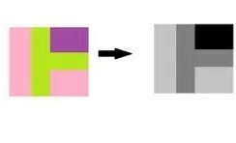

1. **BGR format**

Three hues—blue, green, and red—are present in the images. Each pixel's value is extracted by the computer, which then organises the information into an array for interpretation. Blue, green, and red are the three channels used to depict images.

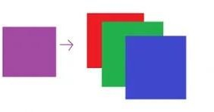

The cumulative probability of B G R is used to determine the hand.

### 6.1.5 ML Pipeline (MediaPipe) for Hand Tracking and Gesture Recognition

A machine learning system called Mediapipe was developed by combining pipeline models.

**What is ML Pipeline?**

A pipeline connects many steps so that the output of one serves as the input for the following.

Using the same preprocessing for training and testing is made simple by pipeline.

**The hand tracking technique utilises a machine learning pipeline made up of two interconnected models:**

• A hand landmark model that produces high-fidelity findings using the palm detector's clipped hand bounding box.

• A palm detector that employs an aligned hand bounding box to locate palms on an entire input picture. buildings in 2.5D

The pipeline is summarised in the chart below.:

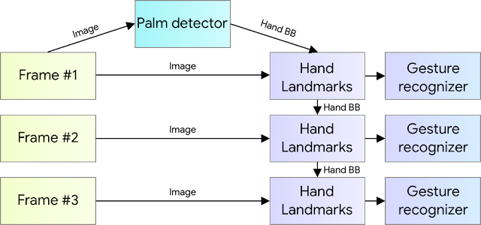

**Fig 7:** Working of Palm detection

**6.1.6 Palm Detector Model**

It takes a lot of time to detect hands since they come in a variety of sizes, shapes, and abnormalities. Since there is far less contrast in features than there is in faces, it is more difficult to distinguish faces.

We start with a palm detection model since it is far simpler to identify a palm or a fist than a whole hand with articulated fingers. Additionally, because palms are smaller, non-suppression algorithms perform better on them.

**6.1.7 Hand Landmark Model**

A hand landmark model is then utilised to identify 21 landmark locations in 2.5 dimensions following the detection of the palm using a palm detection model. An image depth map is used to examine the Z depth. The model flawlessly distinguishes between hands that are partially and completely occluded.

Three results from the model are shown in Figure 8:

1. A total of 21 hand landmarks with x, y, and relative depth.

2. The presence of a hand in the input picture is indicated by a hand flag.

3. A categorization of handedness as either left or right.

The 21 landmarks share the same topography. The probability of hand presence in a bounded crop is calculated in order to avoid conducting hand detection again for the whole frame. If the score is below than a certain level, the detector is activated to restart tracking. To determine whether the input hand is on the left or right, we built a binary classification head. The detector is only utilised in the initial frame or when the hand prediction indicates that the hand has been lost.

The fingers are assigned Ids ranging from 0 to 4 for our project.

**Fig 8:** Palm Land Marks

**6.1.8 working model**

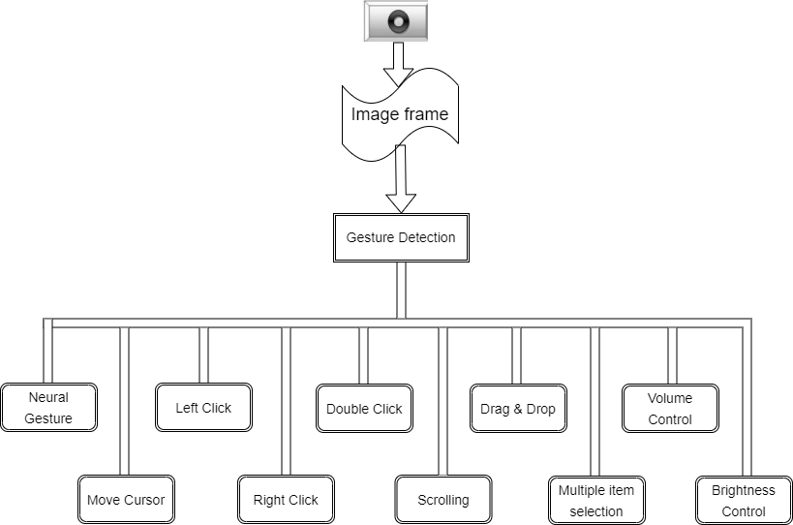

**Fig 9:** Working model of Virtual Mouse

## 6.1.9 Features

## Mouse Features Using Computer Vision to Determine Hand Gestures and Hand Tip Detection

### Neutral Gesture

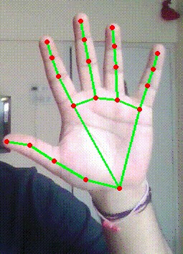

* + 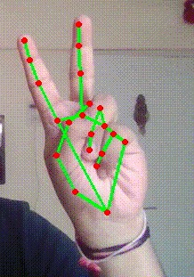**Move Cursor**

To move around the computer window, utilise the mouse pointer.

The mouse pointer may be made to travel around the computer window if the middle finger with tip Id 2 and the index finger with tip Id 1 are both up.

### Left Click

The index finger with Tip ID 1 and the middle finger with Tip ID 2 must both be up in the first frame for the mouse to make a left click, and in the second frame, the index finger with Tip ID 1 down and the middle finger with Tip ID 2 up, both creating angles larger than 33.5°.

### Right Click

* + 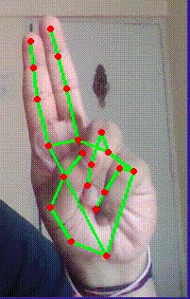**Double Click**

### Scrolling

* + 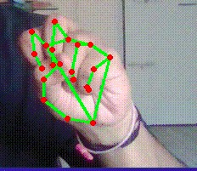**Drag and Drop**

### Multiple Item Selection



* + 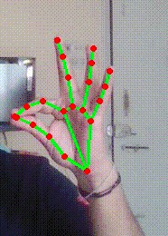**Volume Contro**
* **BRIGHTNESS CONTROLL**

**6.2 Chatbot**

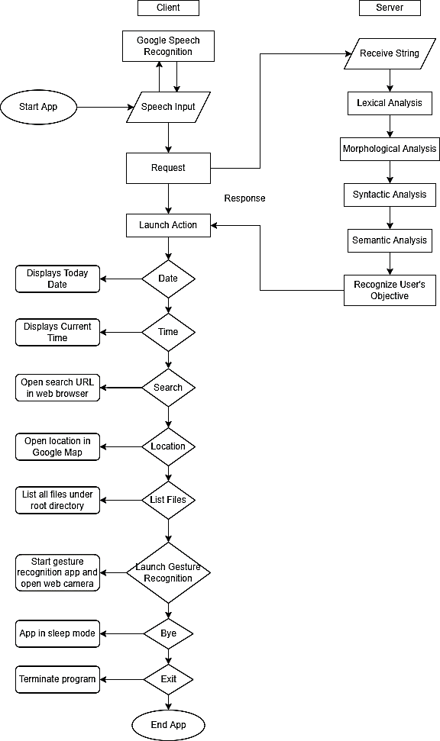**6.2.1 Flow-Chart**

**Fig 10:** Flowchart of Chatbot

**6.2.2 Data Flow Diagram (DFD)  
Level-0**

**Fig 11:** Level-0 DFD of Chatbot

**Level-1**

**Fig 12:** Level-1 DFD of Chatbot

**6.2.3 Features**

* **Joke**
* **Greeting**
* **Paste**
* **Copy**
* **Deactivate Virtual Mouse**
* **Activate Virtual Mouse**
* **Search**
* **Favorite Song**

**6.2.4 Working Model**

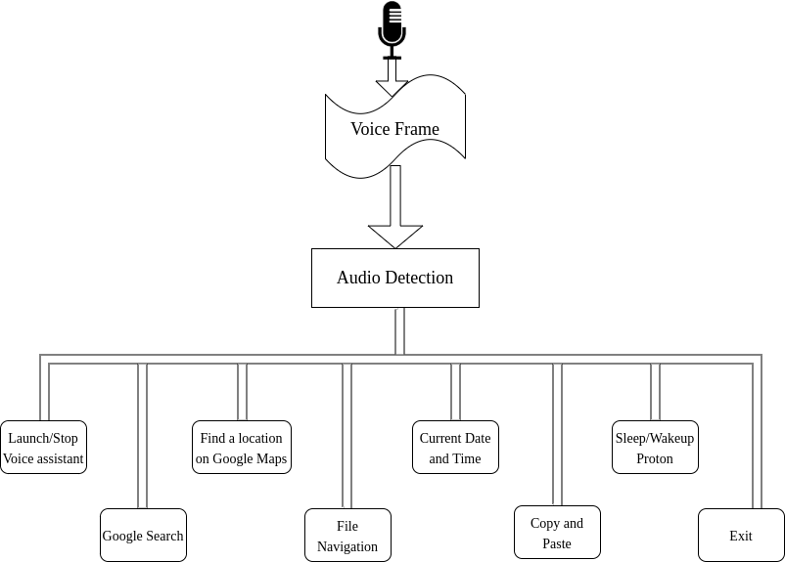

**Fig 13:** Working model of Chatbot

# Hardware and Software Requirement

**7.1 Hardware Requirement**

The following hardware is needed to create and run the Virtual Mouse application:

* **Laptop or Computer Desktop**

On the laptop or computer desktop, the virtual programme will be launched to display the webcam's captured images.

The system will employ a Core2Duo CPU (minimum specifications) from the second generation.

Main memory is 2 GB. Hard drive, 320 GB

14-inch LCD screen

* **Webcam**

The picture is taken using a camera that will take pictures indefinitely so that the programme can analyse it and figure out where each pixel is.

Resolution: A minimum of 1.3 megapixels is required.

* **Microphone**

The microphone records spoken orders. It will continue to respond to all orders up until it is turned off or put to sleep.

A microphone should be able to detect frequencies between 40Hz and 16KHz.

**7.2 Software Requirement**

The creation and operation of the Virtual Mouse application require the following software:

* **Python Language**

Microsoft Visual Studio Code, an integrated development environment (IDE) for creating computer programmes, is used to programme the Python-based Virtual Mouse application.

The Python library includes functions for basic math, bit manipulation, indirection, comparisons, logical operations, and more.

* **Open CV Library**

OpenCV was used to construct this programme as well.

A real-time computer vision library is called OpenCV (Open-Source Computer Vision). Real-time eye tracking and blink detection are also possible with OpenCV in addition to reading image pixel values.

Using software will be:

OS: 64-bit Windows 10 Ultimate English Python

Tool used: MediaPipe and OpenCV

# Applications

The virtual mouse method is useful for many applications. It may be used in situations when a physical mouse is not accessible as well as to conserve space by removing the requirement for one. By eliminating the requirement for a hardware device (mouse), this technology improves human-computer connection.

Major applications:

* Can reduce physical stress on the body, which, among other things, can lead to bad posture, back pain, and visual problems.
* The suggested virtual mouse may be used to control the computer without using the real mouse since it is unsafe to operate equipment by touching it during the COVID-19 outbreak because doing so could allow the virus to spread.
* This technology can control automation systems and robots without the use of any additional devices.
* On the virtual system, hand gestures may be utilised to design 2D visuals.
* A virtual mouse may be used to play augmented reality and virtual reality games instead of a wireless or cable mouse.
* Those who have trouble using their hands to operate computer mouse functions can utilise this virtual mouse.
* You can swiftly and effectively carry out the tasks of a conventional mouse by combining gesture and voice control.

# Limitations

* The results of gesture and speech recognition may be hampered by a few current environmental difficulties in this project.
* Some background disturbances might make it more difficult to discern the intended command when using voice recognition. Another difficult aspect is recognising various accents and executing the correct orders.
* Furthermore, the webcam/mic's processing speed and/or resolutions might have an impact on the program's load, making the hardware of the user a key factor in the program's performance. As a result, the processing speed and/or resolutions are slower the longer it takes to complete a single instruction.
* Furthermore, the webcam/mic's processing speed and/or resolutions might have an impact on the program's load, making the hardware of the user a key factor in the program's performance. As a result, the processing speed and/or resolutions are slower the longer it takes to complete a single instruction.

# 10. Future Scope

The traditional computer mouse will soon be replaced by the virtual mouse, making it simpler for users to connect to and control their computers. The software must be quick enough to record and process every picture and vocal instruction in order to accurately track the user's gesture.

To make the programme more user-friendly, accurate, and adaptive in various circumstances, more features and enhancements might be made. The improvements and features that are necessary are as follows:

### Smart Recognition Algorithm

Additional operations like extending and contracting the window, among others, may be carried out by using the palm and a large number of fingers.

### Better Performance

The hardware of the computer, including the processing speed of the CPU, the amount of RAM available, and the features of the camera, has a significant impact on reaction time. As a result, the software may run more effectively when used on a reliable computer equipped with a camera that performs well in a variety of lighting situations and a better-quality microphone that can quickly and accurately recognise spoken commands.

# 11. Conclusion

Using hand gestures and vocal instructions, the virtual mouse system's primary objective is to enable users to operate the mouse pointer and carry out tasks without the usage of a real mouse. This system is produced by utilising a webcam (or any built-in camera) that identifies hand gestures and hand tip movement and processes these frames to conduct the necessary mouse movements. The system also utilises the idea of speech recognition to swiftly follow voice directions and perform mouse activities.

After extensive testing, the model has shown to be extremely accurate and complex, exhibiting significant gains over earlier existing models. The virtual mouse may be utilised for real-time applications since the suggested model has been thoroughly evaluated for high complexity. In the current environment, the suggested mouse system will be more useful in preventing the spread of viruses like COVID-19 since it can be operated digitally using hand gestures and voice instructions rather than the conventional physical mouse.

It includes all mouse functionalities and serves as a handy user interface. More precise hand detections are now achievable thanks to research into cutting-edge mathematical materials for image processing and the examination of various hardware options. This prototype not only demonstrates the many gesture operations and voice commands that users may utilise, but it also illustrates the possibilities for streamlining user interactions with hardware devices and personal computers. The ability to operate with a more complicated backdrop and in accordance with various lighting situations, however, may be a significant expansion of this work.

**12. Plagiarism Test**

In our project named THATHASTU, we are thrilled to announce that we have achieved an impressively low plagiarism score of 16.08%. THATHASTU is an innovative combination of a Gesture Control Virtual Mouse and a Voice Control AI Chatbot. With painstaking research and development, we have managed to create a unique and original solution that stands out in the field. Our team's commitment to ethical practices and intellectual integrity has resulted in a remarkably low similarity index, showcasing our dedication to producing authentic work. We are proud to present THATHASTU as a testament to our originality and commitment to delivering cutting-edge technology.

**Fig 14:** Plagiarism relation chart

# 13. References

[1]. Himanshu Bansal, Rijwan Khan, “A review paper on human computer interaction” International Journals of advanced research in Computer Science and Software Engineering, Volume 8, Issue 4, April 2018

[2]. N. Subhash Chandra, T. Venu, P. Srikanth, “A Real-Time Static & Dynamic Hand Gesture Recognition System” International Journal of Engineering Inventions Volume 4, Issue 12, August 2015

[3]. S. Shiriam, B. Nagaraj, J. Jaya, “Deep learning based real time AI Virtual Mouse system using computer vision to avoid COVID-19 spread”, Hindawi Journal of Healthcare Engineering, October 2021.

[4]. Hritik Joshi, Nitin Waybhase, Ratnesh Litoria, “Towards controlling mouse through hand gestures: A novel and efficient approach”, Medi-caps University, May 2022

[5]. Mohhamad Rafi, Khan Sohail, Shaikh Huda, “Control mouse and computer system using voice commands”, International Journal of Research in Engineering and Technology”, Volume 5, Issue 3, March 2016

**14. Appendix**

**14.1 Table of Contents**

* 1. Hand Landmarks Chart
  2. Architecture of Gesture and Voice Control Application
  3. Flow Chart of Gesture Control

**a. Hand Landmarks Chart**

The following chart shows the different hand landmarks that are used in the Virtual Mouse and AI-Chatbot system:

|  |  |
| --- | --- |
| **Landmark** | **Description** |
| Wrist | The base of the hand |
| Thumb | The thumb of the hand |
| Index Finger | The index finger of the hand |
| Middle Finger | The middle finger of the hand |
| Ring Finger | The ring finger of the hand |
| Pinky Finger | The pinky finger of the hand |

**b. Architecture of Gesture and Voice Control Application**

The following diagram shows the architecture of the Gesture and Voice Control Application used in the Virtual Mouse and AI-Chatbot system:



**Fig 15:** Architecture of Application

**c. Working Model of Gesture Control**

The following flow chart shows the process of controlling the Virtual Mouse through hand gestures:



**Fig 16:** Working model of Gesture Control